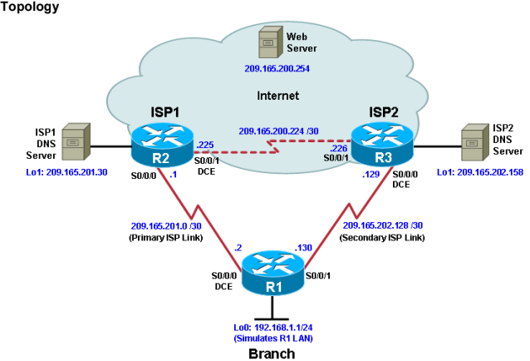

R1

conf t

hostname R1

interface Loopback 0

description R1 LAN

ip address 192.168.1.1 255.255.255.0

interface Serial5/0

description R1 --> ISP1

ip address 209.165.201.2 255.255.255.252

clock rate 128000

bandwidth 128

no shutdown

interface Serial5/1

description R1 --> ISP2

ip address 209.165.202.130 255.255.255.252

bandwidth 128

no shutdown

ISp1

conf t

hostname ISP1

interface Loopback0

description Simulated Internet Web Server

ip address 209.165.200.254 255.255.255.255

interface Loopback1

description ISP1 DNS Server

ip address 209.165.201.30 255.255.255.255

interface Serial5/0

description ISP1 --> R1

ip address 209.165.201.1 255.255.255.252

bandwidth 128

no shutdown

interface Serial5/2

description ISP1 --> ISP2

ip address 209.165.200.225 255.255.255.252

clock rate 128000

bandwidth 128

no shutdown

ISP2

conf t

hostname ISP2

interface Loopback0

description Simulated Internet Web Server

ip address 209.165.200.254 255.255.255.255

interface Loopback1

description ISP2 DNS Server

ip address 209.165.202.158 255.255.255.255

interface Serial5/1

description ISP2 --> R1

ip address 209.165.202.129 255.255.255.252

clock rate 128000

bandwidth 128

no shutdown

interface Serial5/2

description ISP2 --> ISP1

ip address 209.165.200.226 255.255.255.252

bandwidth 128

no shutdown

R1# show interfaces description

Router R1

conf t

ip route 0.0.0.0 0.0.0.0 209.165.201.1

exit

Router ISP1 (R2)

conf t

router eigrp 1

network 209.165.200.224 0.0.0.3

network 209.165.201.0 0.0.0.31

no auto-summary

ip route 192.168.1.0 255.255.255.0 209.165.201.2

Router ISP2 (R3)

conf t

router eigrp 1

network 209.165.200.224 0.0.0.3

network 209.165.202.128 0.0.0.31

no auto-summary

ip route 192.168.1.0 255.255.255.0 209.165.202.130

R1

tclsh

foreach address {

209.165.200.254

209.165.201.30

209.165.202.158

} {

ping $address source 192.168.1.1

}

R1

tclsh

foreach address {

209.165.200.254

209.165.201.30

209.165.202.158

} {

trace $address source 192.168.1.1

}

R1

conf t

ip sla 11

icmp-echo 209.165.201.30

frequency 10

exit

ip sla schedule 11 life forever start-time now

exit

R1# show ip sla configuration 11

R1# show ip sla statistics

R1# show ip sla configuration 22

R1# show ip sla configuration 22

R1

config

no ip route 0.0.0.0 0.0.0.0 209.165.201.1

ip route 0.0.0.0 0.0.0.0 209.165.201.1 5

exit

R1# show ip route

R1

config

track 1 ip sla 11 reachability

delay down 10 up 1

exit

R1# debug ip routing

R1# conf t

ip route 0.0.0.0 0.0.0.0 209.165.201.1 2 track 1

R1# show ip route

ISP1

conf t

interface loopback 1

shutdown

R1# show ip route

R1# show ip sla statistics

R1# trace 209.165.200.254 source 192.168.1.1

ISP1

Conf t

ISP1(config-if)# no shutdown

R1# show ip sla statistics

R1# show ip route